Chapter 11, Solution 57.

For the circuit in Fig. 11.76, find the average, reactive, and complex power delivered by the dependent voltage source.

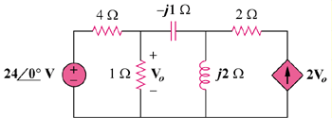

Figure 11.76
For Prob. 11.57.

Solution

Consider the circuit as shown below.

1

2 V_{o}

2

-j1

4

240 V
+

j2

V_{o}

V₁

+

V₂

At node o,
(1)

At node 1,
(2)

Substituting (2) into (1),
,

The voltage across the dependent source is

(50.45–j33.64) VA

